**Disclaimer: The content is curated from online/offline resources and used for educational purpose only**

**Code Repository**

**LAB MANUAL**

**Initializing a Git Repository – Create a New Local Repository and Check Repository Status**

**Objective:**

* To create a new local Git repository using the git init command
* To understand the structure of a Git-enabled folder
* To use git status to view changes and track file states in the repository

**Equipment Required:**

* A computer with Git installed
* Git Bash (Windows) / Terminal (Linux or macOS)
* Basic text editor (Notepad, VS Code, etc.)

**Prerequisites:**

1. Basic knowledge of command line operations
2. Git must be installed and configured (user.name and user.email)
3. Familiarity with file systems and directories

**Problem Statement:**

As a developer starting a new project, you want to use Git to track changes in your files. Your task is to initialize a new Git repository in a local folder and check its status to ensure Git is ready to track file changes.

**Procedure:**

**Step 1: Open Terminal or Git Bash**

* Launch **Git Bash** (Windows) or **Terminal** (macOS/Linux)



**Step 2: Create a New Project Folder**

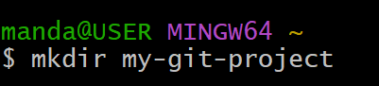

**Step 3: Initialize a Git Repository**



You should see:Initialized empty Git repository in <your_path>/.git/

**Step 4: Create a New File**

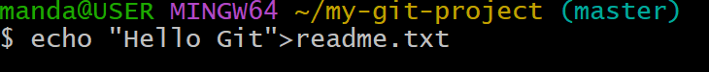

**Step 5: Check Repository Status**

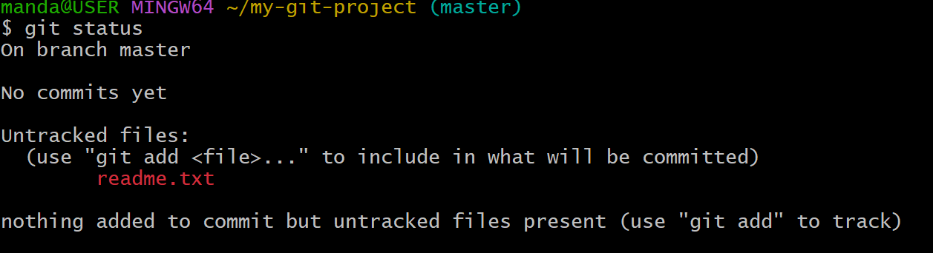

**Step 6: Stage and Commit the File**



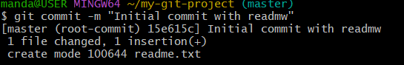

**Step 7: Verify Final Status**

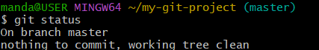

It should now show: nothing to commit, working tree clean